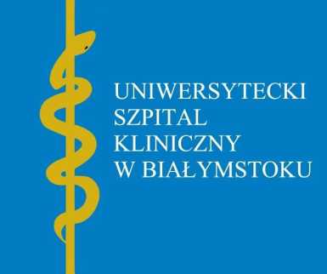

Dear Patient!

According to art. 13 para. 1 and 2 of the Regulation (EU) 2016/679 of the European Parliament
and of the Council dated 27 April 2016 on the protection of natural persons with regard to the processing
of personal data and on the free movement of such data, and repealing Directive 95/46/EC, hereinafter
the GDPR, please be informed that:
1) The administrator of your personal data is the University Clinical Hospital in Bialystok,
ul. M. Skłodowskiej-Curie 24a, 15-276 Bialystok, e-mail address: szpital@uskwb.pl.
2) The University Clinical Hospital appointed a Data Protection Inspector for protection of your personal data: ido@poczta-usk.pl.
3) Your personal data shall be processed for the purpose of providing medical services based
on art. 6 para 1a in the extent to which you have provided your personal data voluntarily under your consent, art. 6 para.1d to the extent necessary to provide health services, art. 9 para. 2c and 2h and for the purpose of providing medical services, health care, managing the provision of medical services at the University Clinical Hospital in Białystok and ensuring the security of the ICT system in which the medical documentation is processed.
4) Your data may be made available to entities authorised to obtain it on the basis of legal regulations (e.g. to the Patient’s Rights Ombudsman, the National Health Fund, the Ministry of Health,
the Social Insurance Institution, self-governing authorities for medical professions, and for the purpose of national and provincial consultations), to other health care entities to ensure
the continuity of treatment, as well as to the founding body of the Administrator (the Medical University of Białystok) in connection with exercising supervision. Your data may be submitted
to entities that process personal data at the request of the Administrator, e.g. providers of IT,
legal, consulting, courier and postal services, whereas such entities process data on the basis
of an agreement with the Administrator and only in accordance with the Administrator's order.
5) Your personal data shall not be transferred to any third country / international organisation.
6) Your personal data shall be stored for the period resulting from the applicable provisions
of law concerning mandatory filing of documentation related to the provision of health services:
- 30 years in the event of death,
- 20-year for medical records,
- 10 years for X-ray scans,
- 5 years for referrals and orders,
- 22 years in case of children's medical records produced in the period up to the age of two.
7) You have the right to access your personal data, rectify it, delete or limit its processing, the right
to transfer your data to another administrator, and the right to raise objections to further data processing. An objection does not affect further processing of the data if there is a legal basis
for further processing.
8) You are required to provide your personal data in the scope of necessary for provision of medical services pursuant to the provisions of the Act dated 6 November 2008 on patient’s rights
and the Patient’s Rights Ombudsman, and the Act dated 27 August 2004 on health care services financed from public funds, while in the remaining scope it is voluntary. You are obliged to provide your personal data to the extent required by medical legislation. Failure to provide your personal data may result in a refusal to provide medical services.
9) You have the right to file a complaint with the Office for Personal Data Protection, when you feel that processing of your personal data violates the provisions of the GDPR.

....................................................
Date and signature of the patient

